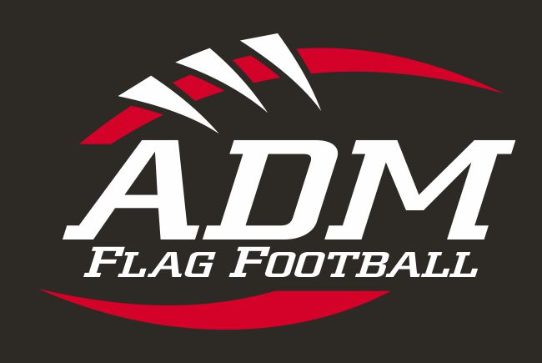 | 2017 ADM K-5 Flag Football Sign-up Sheet  Registration Deadline is: August 25, 2017  Season Dates: September 11, 2017 to October 16, 2017  Games Played: Monday Evenings

Player’s Name: _____________________________ Player’s Age: _____
Player’s Grade (2017-2018 school year): K 1 2 3 4 5 (Please circle one.)
T-shirt Size: YS YM YLG YXL (Please circle one.)
Any Medical Restrictions: _________________________
Emergency Contact Person: ________________________
Emergency Contact Phone Number: __________________

Player’s Mother’s Name: ___________________________________
Address: _____________________________________ _____________________________________
Primary Contact Phone Number: _________________ Home/Cell
Mother’s Email Address: _________________________

Player’s Father’s Name: ____________________________________
Address: _____________________________________ _____________________________________
Primary Contact Phone Number: _________________ Home/Cell
Father’s Email Address: _________________________

If a Parent is willing to volunteer as a coach, either head or assistant, please enter Parent’s name here: _____________________________________________

Sign-up Fee: $45.00 for K-1-2-3 with new jersey*
$60.00 for 4-5 with new jersey* - includes soft helmet
Family Discount of $15.00 for each additional player.
*An ADM Flag Football jersey is required; however, a player may deduct $10.00 if they elect to use last year’s jersey.
(No Cash Please. Make check or money order payable to “ADM FLAG FOOTBALL, INC.”)

PLEASE MAIL COMPLETED FORM AND SIGN UP FEE TO:
ADM FLAG FOOTBALL INC.
c/o Ryan Barthman
1515 Chance Court
Adel, Iowa 50003

Please read and sign the ADM Flag Football Inc. Release and Waiver of Liability, Assumption of Risk and Indemnity Agreement on the back of this form prior to mailing.

For Internal Use Only.

Paid or Not Paid (Circle One) ______ Release/Indemnity Signed by Father/Guardian 1
Money Order# _____ Check# _____ ______ Release/Indemnity Signed by Mother/Guardian 2

Team:_______________ Coach:_______________________
ADM FLAG FOOTBALL INC. RELEASE AND WAIVER OF LIABILITY,
ASSUMPTION OF RISK AND INDEMNITY AGREEMENT
(READ CAREFULLY BEFORE SIGNING)

EVENT: FOR GOOD AND VALUABLE CONSIDERATION THE RECEIPT AND SUFFICIENCY OF WHICH IS HEREBY ACKNOWLEDGED, and IN CONSIDERATION for allowing the below named MINOR participant to compete, officiate, observe, work in, and/or participate in any-way ("Participate") in ADM FLAG FOOTBALL INC. practices, games, events and/or activities ("EVENT(S)"), EACH OF THE UNDERSIGNED PARENT OR GUARDIAN, jointly and severely, for himself/herself, his/her personal representatives, the MINOR and each of their next of kin agrees that:

- THE MINOR and PARENT OR GUARDIAN will immediately inspect the EVENT(S) Area upon entering it and warrants that their entry therein and/or the MINOR'S participation in the EVENT(S) constitutes an acknowledgment that they have inspected the EVENT(S) Area and find it safe and reasonably suited for the purpose of its use. The PARENT OR GUARDIAN each represents and agrees that if at any time in the EVENT(S) Area they believe something is unsafe, it will immediately be brought to the attention of ADM FLAG FOOTBALL INC., a coach and/or official and that they will immediately remove themselves and the MINOR from the EVENT(S) Area and will withdraw the MINOR from Participation in the EVENT(S).
- THE MINOR and PARENT OR GUARDIAN, JOINTLY AND SEVERALLY, HEREBY ASSUME FULL RESPONSIBILITY FOR AND RISK OF BODILY INJURY, PARALYSIS, DISABILITY, DEATH OR PROPERTY DAMAGE due to negligence of the RELEASEES (as identified below) or otherwise, while in or upon the EVENT(S) Area for any purpose and/or related in any way to the MINOR’s Participation in the EVENT(S). The MINOR and PARENT OR GUARDIAN acknowledge, recognize and understand that there are risks and dangers associated with Participation in the EVENT(S) and that Participation in the EVENT(S) and/or admission within the EVENT(S) Area could cause severe bodily injury, paralysis, disability and death. Further, the risks and dangers may be caused by the negligent acts or failure to act of the RELEASEES and others. All of the risks and dangers associated with participating in the EVENT(S) and/or entry into the EVENT(S) Area are assumed not withstanding.
- THE MINOR and PARENT OR GUARDIAN, JOINTLY AND SEVERALLY, release, waive, discharge and covenant not to sue ADM FLAG FOOTBALL INC., the EVENT(S) promoters, sponsor’s, players, officials, coaches, participants, associations, sanctioning organizations, (or any affiliates thereof), advertisers, all persons in the EVENT(S) areas; the owners, lessees and lessors of the premises used to conduct the EVENT(S); and all other persons and entities, and for each of them, their members, officers, agents, and employees (all for the purpose herein referred to as "RELEASEES"), from any and all liability and damages to the PARENT OR GUARDIAN and/or the MINOR, on any legal theory, this includes but is not limited to any and all liability for any and all claims, demands, losses or damages to the MINOR and/or the PARENT OR GUARDIAN, on account of any injury including, but not limited to, the death or injury of the PARENT OR GUARDIAN and/or MINOR or damage to property of the PARENT OR GUARDIAN and/or MINOR, any or all of which is caused or alleged to be caused, in whole or in part, by the acts, omissions, or negligence of the RELEASEES or otherwise.
- THE MINOR and PARENT OR GUARDIAN, JOINTLY AND SEVERALLY, hereby agrees to indemnify, defend, save and hold harmless the RELEASEES and each of them from loss, liability, damage, or cost they may incur, including attorney fees, expert witness fees and legal costs, as a result of, related to, or on account of any injury or death of the PARENT OR GUARDIAN and/or the MINOR and/or damage to property of the PARENT OR GUARDIAN and/or the MINOR, as a result of or related to the presence of the PARENT OR GUARDIAN and/or the MINOR in the EVENT(S) Area, and/or as a result of or related to the MINOR’S participation in the EVENT(S), whether caused or alleged to be caused, in whole or in part, by the acts, omissions, or negligence of the RELEASEES or otherwise. The PARENT OR GUARDIAN further specifically recognize, represent, acknowledge and warrant that they have the authority to execute this RELEASE AND WAIVER OF LIABILITY, ASSUMPTION OF RISK AND INDEMNITY AGREEMENT (“RELEASE”) on behalf of and for himself/herself, his/her personal representatives, the MINOR and each of their next of kin.
- This RELEASE extends to all acts of negligence by the RELEASEES, INCLUDING NEGLIGENT RESCUE OPERATIONS and is intended to be as broad and inclusive as is permitted by the laws of the State of Iowa, and that if any portion thereof is held invalid, it is agreed that the balance shall, notwithstanding, continue in full legal force and effect.

I, THE UNDERSIGNED PARENT OR GUARDIAN OF THE MINOR, HAVE READ THIS RELEASE AND WAIVER OF LIABILITY, ASSUMPTION OF RISK AND INDEMNITY AGREEMENT, FULLY UNDERSTAND ITS TERMS, UNDERSTAND THAT I AND THE MINOR HAVE GIVEN UP SUBSTANTIAL RIGHTS BY SIGNING IT, AND HAVE SIGNED FREELY AND VOLUNTARILY, INDIVIDUALLY AND ON BEHALF OF THE MINOR, WITHOUT ANY INDUCEMENT, ASSURANCE OR GUARANTEE BEING MADE TO ME AND INTEND MY SIGNATURE TO BE A COMPLETE AND UNCONDITIONAL RELEASE OF ALL LIABILITY AND FULL INDEMNIFICATION OF THE RELEASEES TO THE GREATEST EXTENT ALLOWED BY LAW.

Minor Participant’s Name:_______________________________________ Age of Minor:_______________

_________________________________________ ___________
Minor Participant’s Father (Guardian 1) Signature Date
Printed Name of Minor Participant’s Father (Guardian 1): __________________________________

_________________________________________ ___________
Minor Participant’s Mother (Guardian 2) Signature Date
Printed Name of Minor Participant’s Mother (Guardian 2): __________________________________

EACH PARENT/GUARDIAN OF THE MINOR PARTICIPANT MUST SIGN THIS FORM

